1. TITLE PAGE:
PROJECT: CONTEXT SWITCHING ANALYZER

COURSE: OPERATING SYSTEM

Name | Roll No
1. Muhammad Mujtaba Khalid | 2024S-BCYS-004
2. Muhammad Ahmed Raza | 2024S-BCYS-008
3. Ayaan Shoukat | 2024S-BCYS-037

SUBMITTED BY

TEACHER:

SIR ADIL

SUBMISSION DATE:

26-JANUARY-2026

SEMESTER PROJECT REPORT

2. ABSTRACT
This project presents a functional simulation of an Operating System Kernel designed to demonstrate the core concepts of CPU Scheduling and Context Switching. The primary objective was to visualize how a Round Robin Scheduler manages multiple concurrent processes by allocating specific time slices, known as "Quantums," to ensure fair execution. Using a custom-built interface, the system tracks the lifecycle of various processes—from arrival and PCB allocation to their final execution state. The simulation provides real-time insights through a Context Switching Analyzer, showing the movement of processes between the Ready Queue and the CPU Core. The final outcome is a comprehensive Kernel Audit Report that calculates critical performance metrics, including arrival times, start times, and total system uptime.

CONTENTS
1. TITLE PAGE 1

2. ABSTRACT 2

4. INRODUCTION 4

5. PROBLEM STATEMENT 5

6. TOOLS & TECHNOLOGIES USED 6

7. SYSTEM DESIGN / METHODOLOGY 6

8. IMPLEMENTATION DETAILS 7

9. CONCLUSION 10

4. INTRODUCTION
Background of the Project; In modern computing, the Operating System acts as a bridge between hardware and software, where the Kernel is responsible for managing system resources. One of the most critical tasks of the Kernel is CPU Scheduling, which determines the order in which processes are executed. This project simulates a "Context Switching Analyzer" that visualizes how a system handles multiple processes—specifically PROC_ALPHA, BETA, GAMMA, DELTA, and SIGMA using a structured scheduling approach
Purpose and Objectives The primary purpose of this project is to demonstrate the mechanics of the Round Robin (RR) Scheduler, a preemptive algorithm that assigns a fixed time unit to each process. The specific objectives include:
- Visualizing the transition of processes between the Ready Queue and the CPU Core.
- Understanding the role of the Process Control Block (PCB) in saving and restoring process states during a switch.
- Analyzing the overhead caused by Context Switching (SW), where the system switches from one process to another.
- Monitoring real-time performance through a live Uptime Clock and Switch Counter.
Scope of the Project The scope of this simulation involves the initialization of a system kernel and the subsequent management of five distinct processes with varying arrival times. The system tracks the "Quantum" time (set at 07s in this simulation) and performs a context switch whenever a process exceeds its allotted time or a new priority event occurs. The project concludes with a "Simulation Complete" state after a total system uptime of 220 seconds, producing a comprehensive history log for auditing.

5. PROBLEM STATEMENT
Clear Definition of the Problem Being Solved In a standard computing environment, the CPU is significantly faster than other system components, yet it can only execute one instruction at a time per core. The challenge lies in managing multiple active processes (such as PROC_ALPHA, PROC_BETA, etc.) so that each receives enough CPU time to complete its task without making other processes wait indefinitely. Without an efficient scheduling algorithm, a single long-running process could "starve" others, leading to system lag or unresponsiveness. This project specifically addresses the implementation of a Round Robin Scheduler to solve the issue of fair resource distribution by enforcing a strict Quantum time limit of 07s for every process.
Motivation and Relevance The motivation behind this project is to understand the technical "overhead" created during a Context Switch (SW). Every time the kernel switches from one process to another (e.g., from PROC_ALPHA to PROC_BETA), it must save the current state of registers (such as R1, R2, R3 seen in the CPU Core) and load the state of the next process.
The relevance of this simulation is highlighted by the following needs in modern Software Engineering:
- Multitasking Efficiency: To ensure that the "Ready Queue" is managed dynamically as new processes like PROC_SIGMA arrive at different time intervals (e.g., T+40s).
- Predictability: To calculate and analyze the "Final Statistics," such as why PROC_DELTA, which arrived at T+20s, did not finish until T+219s.
- Resource Optimization: To visualize how the system handles a total uptime of 220s while maintaining a constant flow of execution without kernel crashes.

6. TOOLS & TECHNOLOGIES USED
- Programming Language: Python (Terminal-based UI).
- Operating System: Linux/Unix (based on the cat command and shell styling).
- Features: Round Robin Scheduler, PCB Block Allocator.

7. SYSTEM DESIGN / METHODOLOGY
- Logic: The system uses a Round Robin (RR) algorithm with a fixed Quantum of 07s. Processes are placed in a Ready Queue.
- System Flow:
  - Initialize Kernel and allocate PCB blocks.
  - Process arrives (ARR) and enters the Ready Queue.
  - CPU executes the process for the duration of the Quantum.
  - Context Switch (SW) occurs, moving the current process to the back of the queue and loading the next.
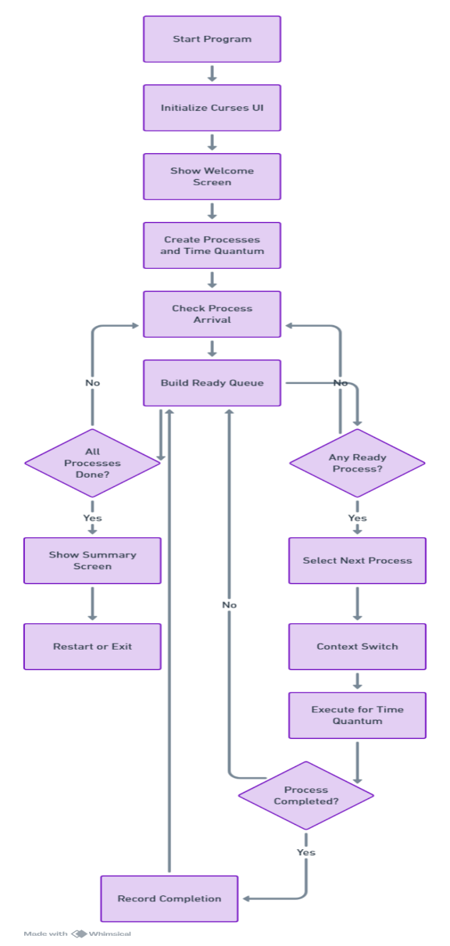
- Flow Chart:

8. IMPLEMENTATION DETAILS

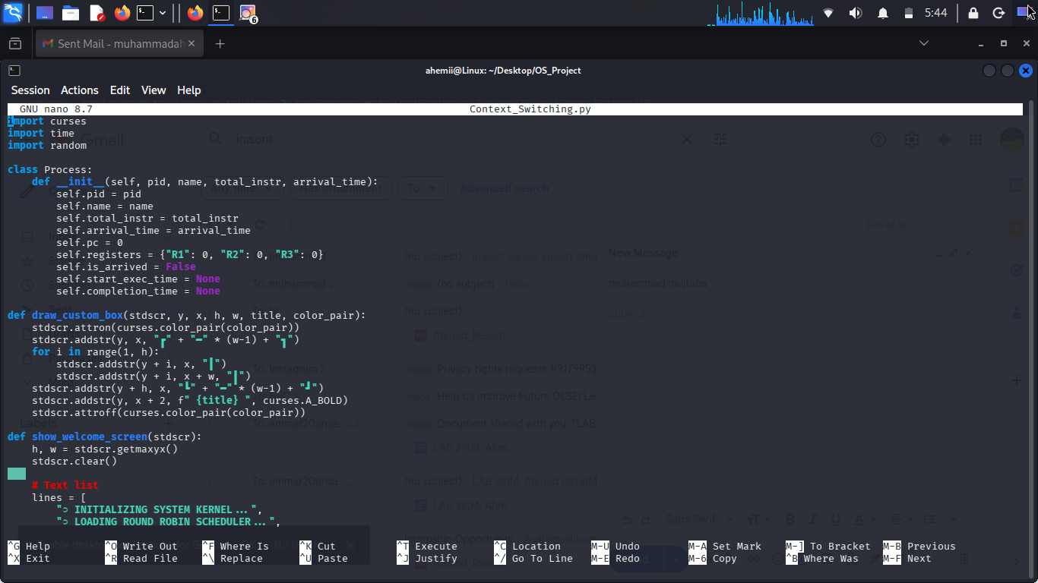
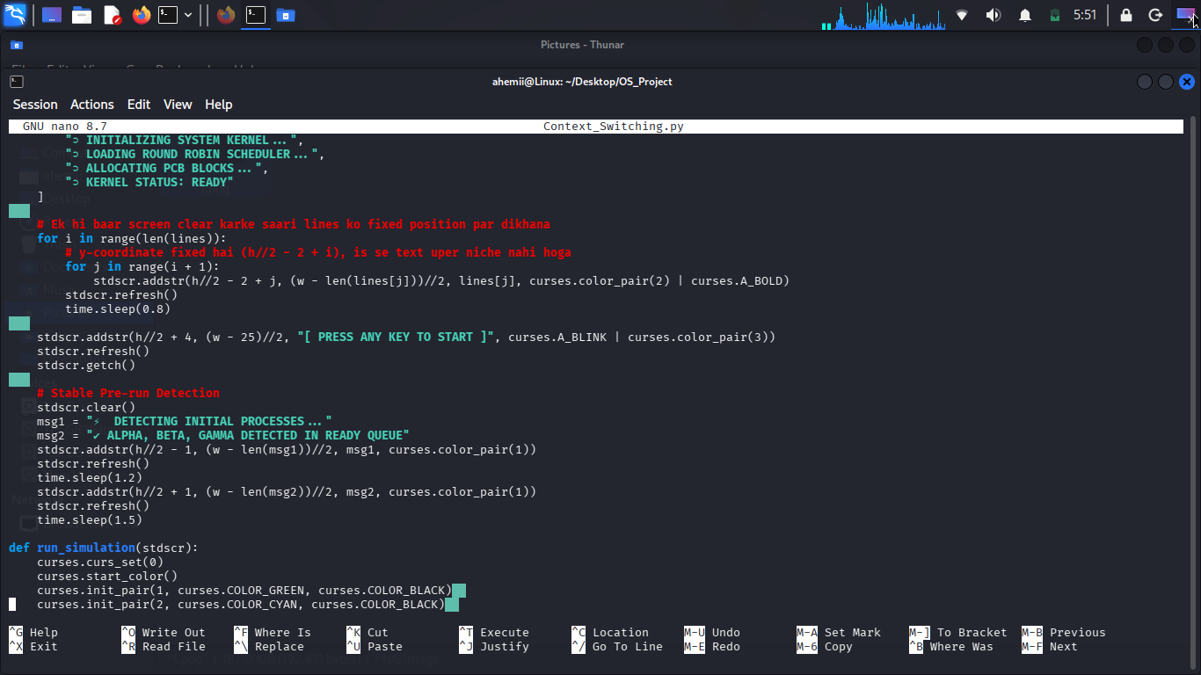

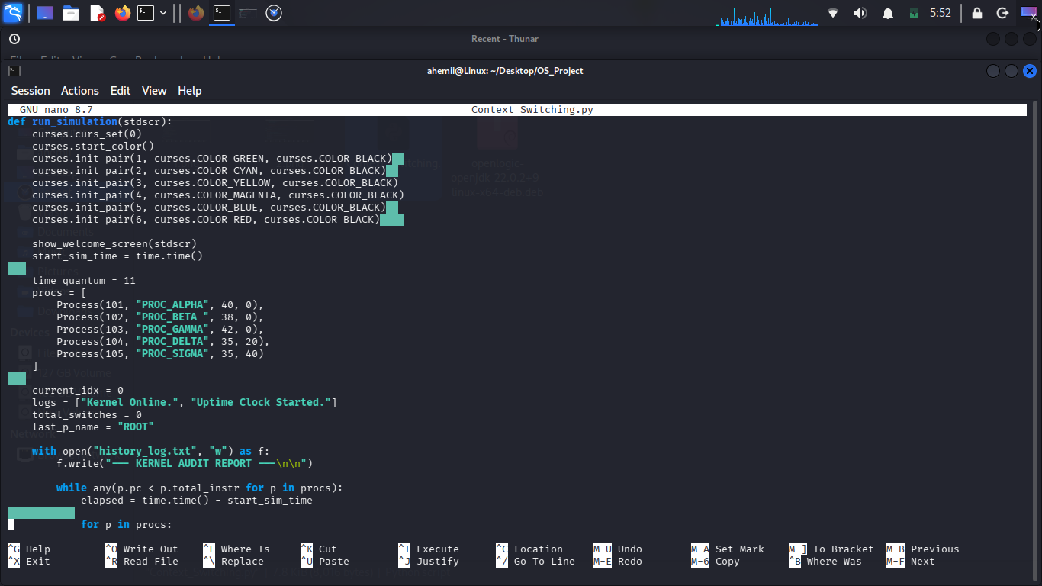

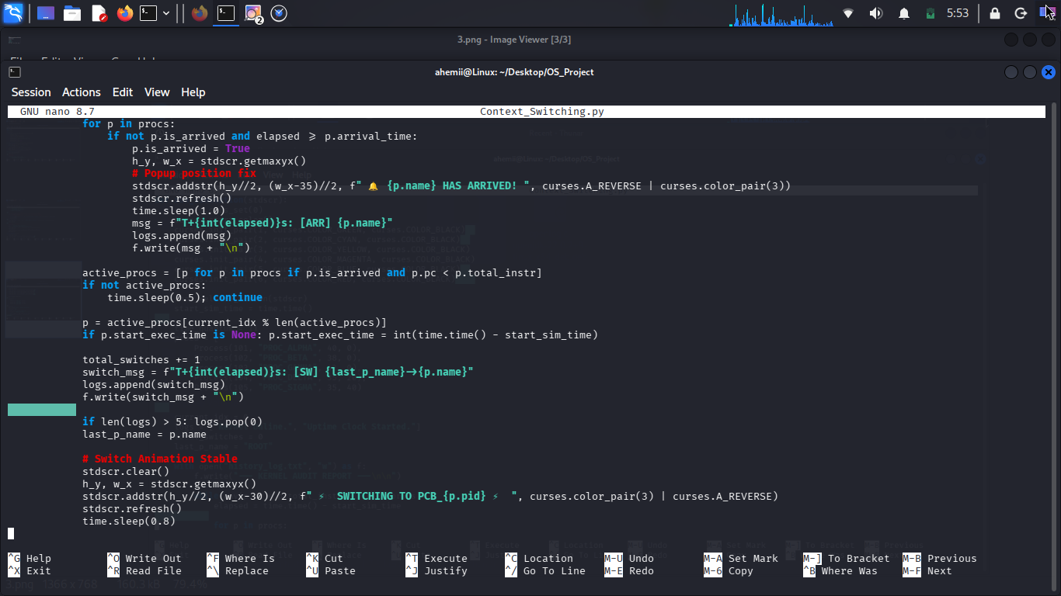

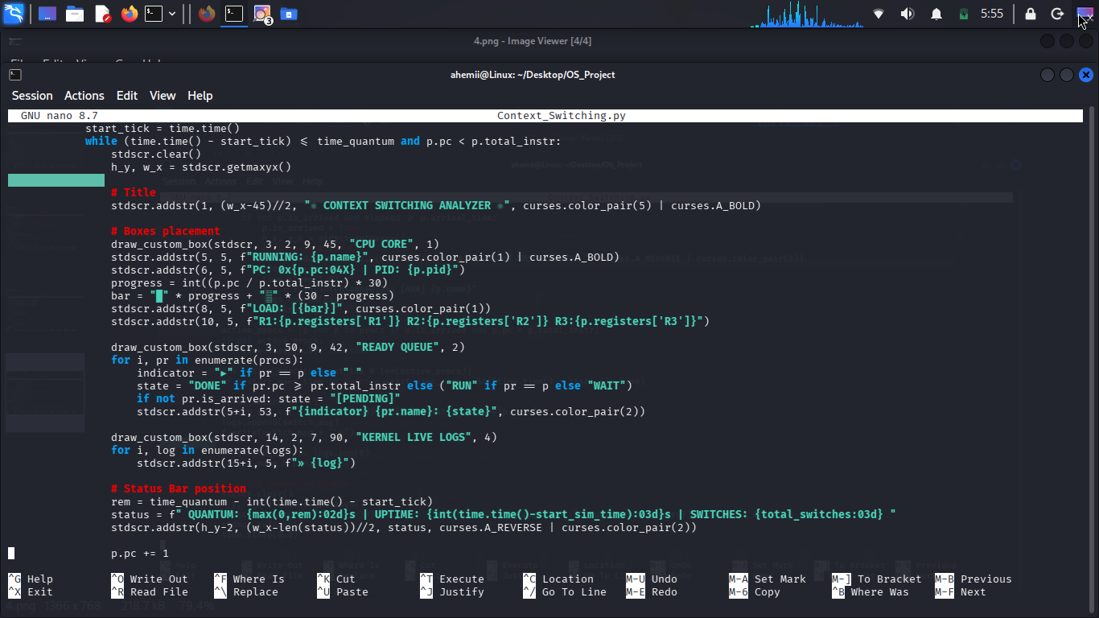

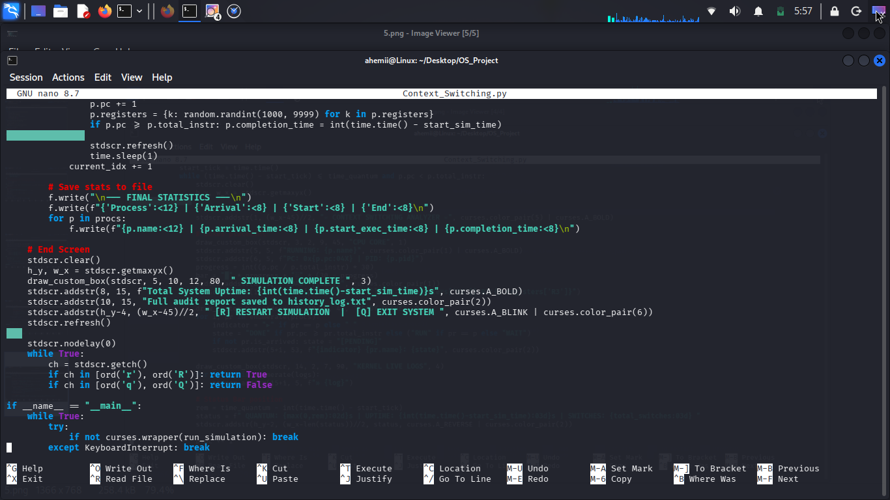

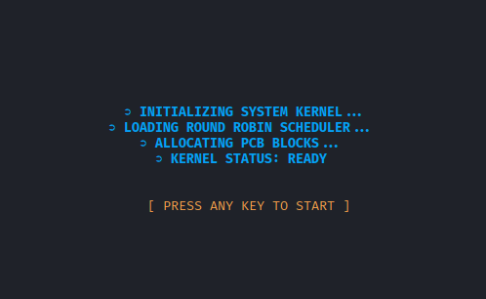

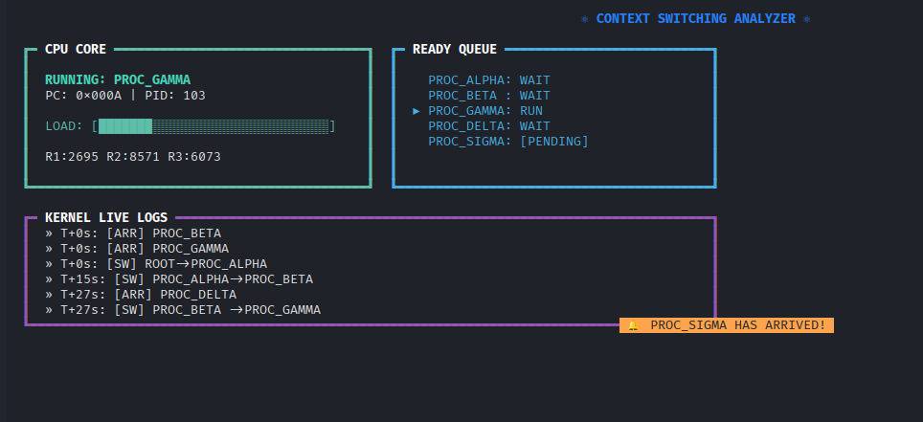

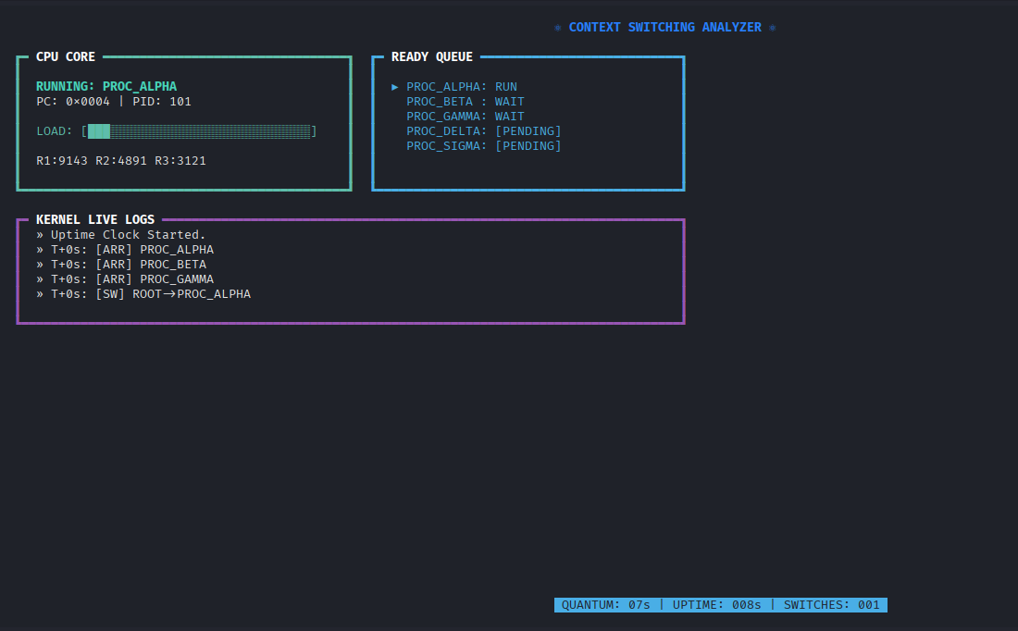
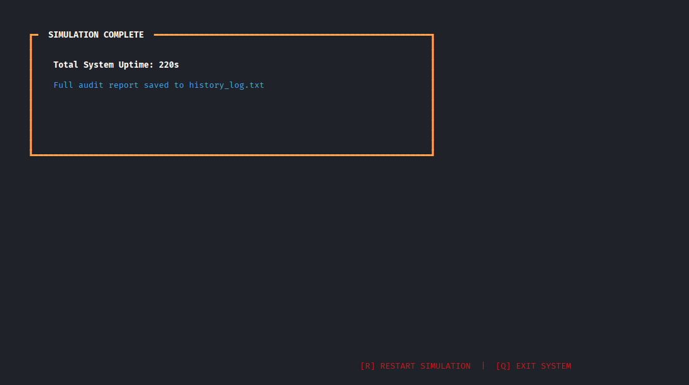
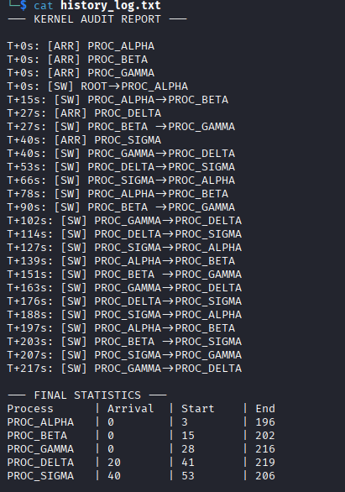

9. CONCLUSION
• Summary: The simulation successfully ran for a Total System Uptime of 220s, handling 5 processes with multiple context switches.
• Learning Outcomes: We have gained a deep understanding of how the kernel manages the Ready Queue and how context switching allows for the illusion of parallel execution
• Books
- Operating System Concepts by Silberschatz, Galvin, and Gagne (often referred to as the "Dinosaur Book") – used for understanding Round Robin algorithms and PCB structures.
- Modern Operating Systems by Andrew S. Tanenbaum – used for studying context switching overhead and kernel design.
• Websites
- GeeksforGeeks: Operating Systems - Process Management and CPU Scheduling.
- TutorialsPoint: Round Robin Scheduling Algorithm and Process States.
• Documentation Links
- Operating System: Process Control Block (PCB) - GeeksforGeeks https://www.geeksforgeeks.org/process-control-block-in-operating-system/
- CPU Scheduling Algorithms Overview - TutorialsPoint https://www.tutorialspoint.com/operating_system/os_process_scheduling_algorithms.htm

